**PRACTICAL NO: 1**

**AIM:** Install DHCP server.

**THEORY:**

1. Dynamic Host Configuration Protocol Daemon (DHCPD), the DHCP server, is responsible for serving IP addresses and other relevant information upon client request.
2. Since DHCP is broadcast-based, a server will have to be present on each subnet for which DHCP service is to be provided.
3. Dynamic Host Configuration Protocol (DHCP) is a network management protocol used to automate the process of configuring devices on IP networks,

Thus allowing them to use network services such as DNS, NTP, and any communication protocol based on UDP or TCP.

1. A DHCP server dynamically assigns an IP address and other network configuration parameters to each device on a network so they can communicate with other IP networks.
2. DHCP is an enhancement of an older protocol called BOOTP. DHCP is an important part of the DDI solution.

Features of DHCP can be explained as:

* DHCPOFFER - The server will host (342 bytes).
* DHCPREQUEST - Client responds by broadcasting
* DHCPDISCOVER - First message generated between server & client (342 or 576 bytes).
* DHCPDECLINE - If IP address already in use, DHCP declines server.
* DHCPRELEASE - Client sends DHCP release packet to server to release IP address & cancel any remaining lease time.
* DHCPINFORM - Domain name.
* DHCPACK/DHCPNAK - Server will make entry [static ip to server].

**COMMANDS & OUTPUT:**

1. Command to install dhcp-server:

$ sudo apt-get install -y isc-dhcp-server

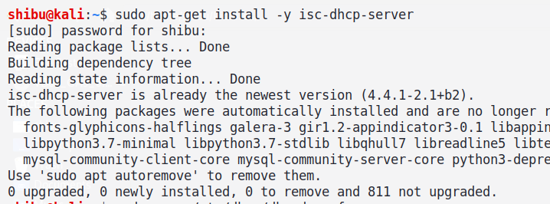

1. Then we need to configure our dhcpd.conf by directly editing through a path:

$ sudo nano /etc/dhcp/dhcpd.conf

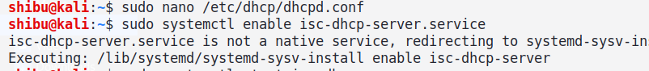

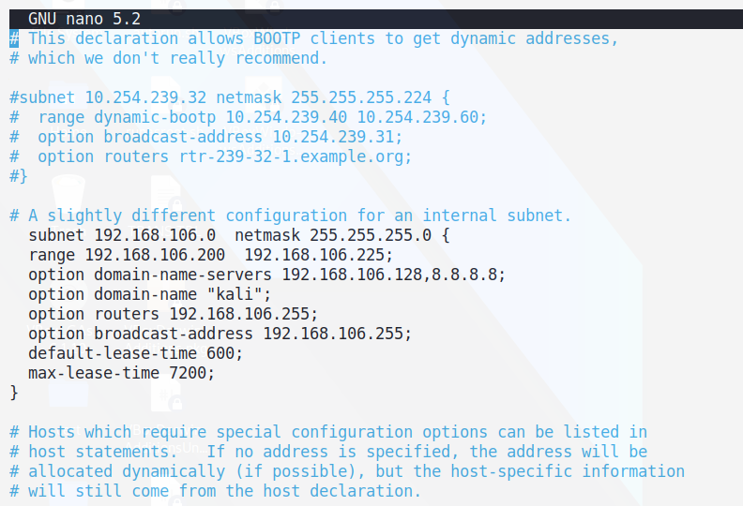

1. To know about ip address of our machine the following command can be given as:

$ ip a (OR) $ ip addr

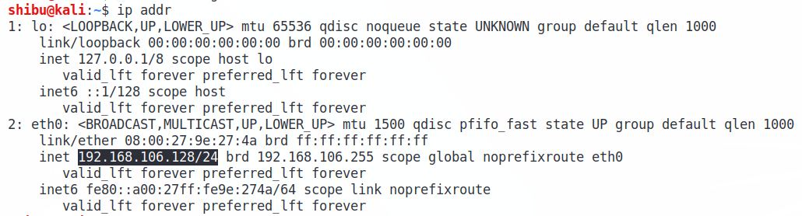

1. Then we configure the subnet and the netmask, after configuring it then save the file and exit. (press[esc] and :wq!)
2. Now we must edit /etc/default/isc-dhcp-server:

$ sudo vi /etc/default/isc-dhcp-server

$ cat /etc/default/isc-dhcp-server

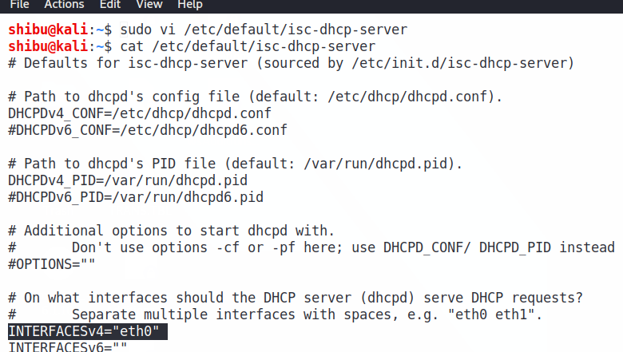

1. Now start & check the status of the service:

$ sudo systemctl start isc-dhcp-server.service

$ sudo systemctl status isc-dhcp-server.service

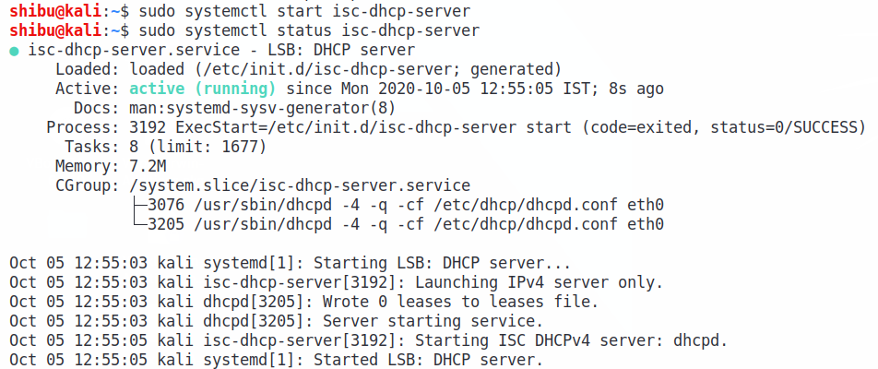

1. If the, service gets failed, then we can use ifconfig eth0 <ip address> netmask <0.0.0.0>

$ sudo ifconfig eth0 192.168.106.128 netmask 255.255.255.0

$ ip addr

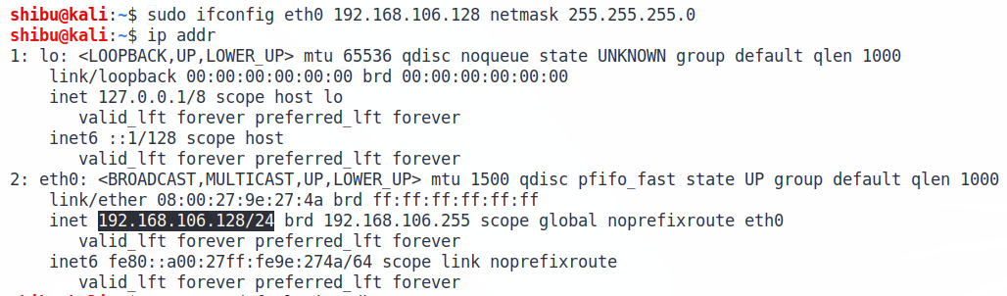

And then restart and check the status of **isc-dhcp-server**

1. Now to test the DHCP:

$ sudo dhcpd -T eth0

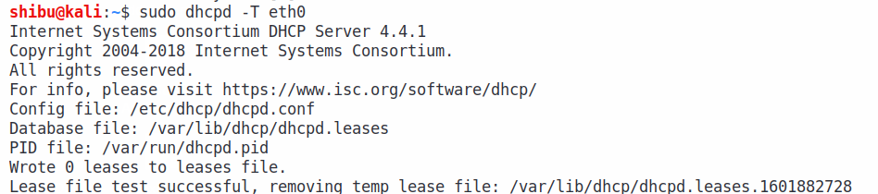

**PRACTICAL NO: 2**

**AIM:** Initial settings: Add a user, Network settings, Configure services and List of services.

**THEORY:**

1. Adding a user:

A user is one who works on the machine simultaneously or it has the permissions to read, write and execute one file or all files. A user can be added individually or in a group.

1. Network settings:

The ip address, ethernet connections and other network connections can be seen through using the command:

$ sudo ip a (OR) $ sudo ip addr

1. Configuring services:

The services that run in the background are also known as daemons, services usually have a 'd' in last of their name, this denotes as a daemon. There are 5 services,

1. Enable
2. Start
3. Status
4. Stop
5. Restart

**COMMANDS & OUTPUT:**

1. Adding a user:

$ sudo adduser <username>

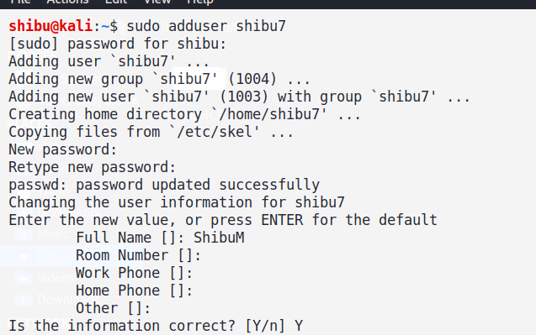

1. Network settings:

$ sudo ip a (OR) $ sudo ip addr

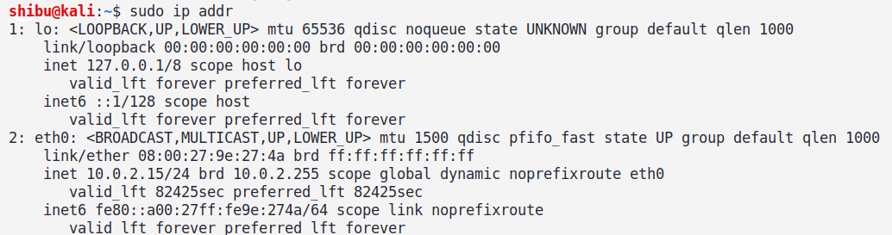

1. Configuring services:

Here, I’ve taken SSH service for demonstration

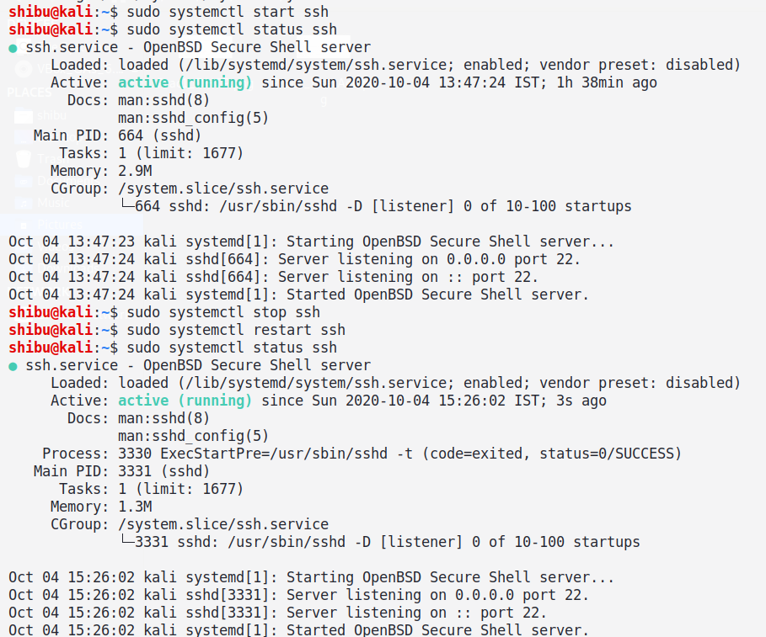

**PRACTICAL NO: 3**

**AIM:** Configure NFS server to share directories or files on your network.

**THEORY:**

1. The Network File System (NFS) is a client/server application that lets a computer user view and optionally store and update files on a remote computer as though they were on the user's own computer.
2. The NFS protocol is one of several distributed file system standards for network-attached storage (NAS). NFS is kind of Google Drive.

There are 3 types of NFS:

1. NFSv2: -

* In these requests are based on per host basis and not on a per user.
* Convenient for whole system.
* TCP or UDP support.
* File size limitation is less than 2GB.

1. NFSv3: -

* Bugs fixes of NFSv2, more features and more performance gain.
* TCP or UDP support.
* Support 2GB on server and more than 2GB on client.
* Support is based on server file limit.

1. NFSv4: -

* Uses stateful protocol TCP or SCTP (Stream Control Transmission Protocol).
* More security features and Kerberos.
* Here, client authentication is per user basis and not per host basis.
* RPC (Remote Procedure Calls).
* It listens on port 2049.

**COMMANDS & OUTPUT:**

1. Install NFS server:

$ sudo apt-get -y install kernel-server

$ sudo apt-get -y install nfs-kernel-server

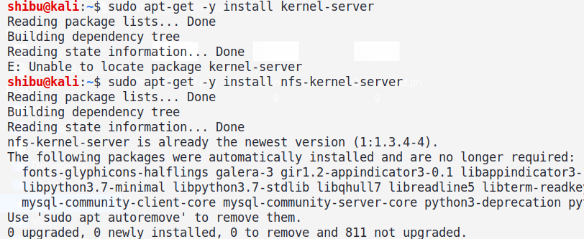

1. Command to enable a service:

$ sudo systemctl enable nfs-kernel-server

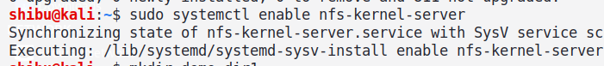

1. Now user needs to create a directory to show the function of NFS that is the mounting process:

$ mkdir demo_dir1

$ vi b.txt

$ ls b.txt

$ mv b.txt demo_dir1

$ ls /home/shibu/demo_dir1

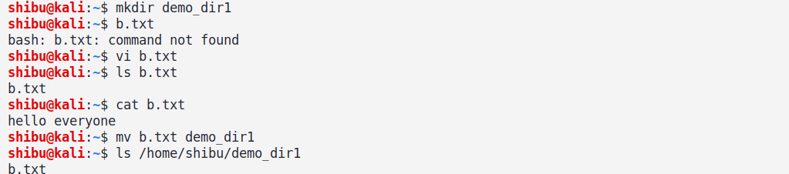

1. Now we have to mention our /directory_path ip_address (permissions), we need to give rw (read,write) permission,

$ sudo vi /etc/exports

$ cat /etc/exports

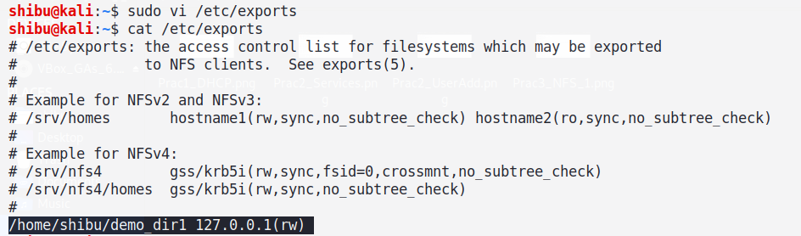

After mentioning the /directory_path ip_address (permissions), it should look like this.

**/home/shibu/demo_dir 127.0.0.1(rw)**

1. Now to check the exports:

$ sudo exportfs -ra

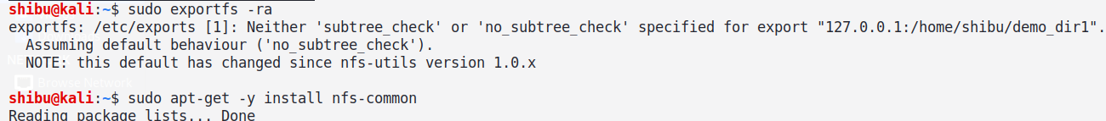

1. To allow file sharing between systems on your network, install:

$ sudo apt-get -y install nfs-common

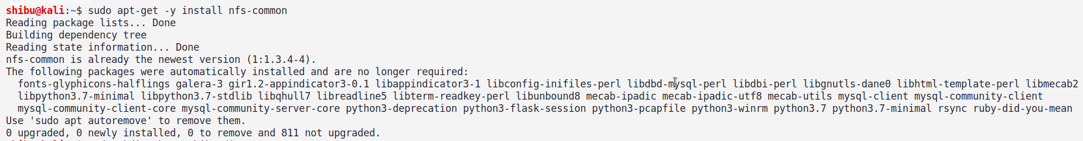

**Note:** Before mounting make sure that the user have made a directory to mount the file, if not the write the command to do so:

$ sudo mkdir /home/shibu_directory

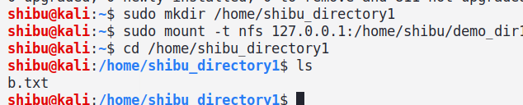

1. Now to mount the file and then the user can check for the mounted file in the directory that user has made:

$ sudo mount -t nfs 127.0.01:/home/shibu/demo_dir /home/shibu_directory

$ ls

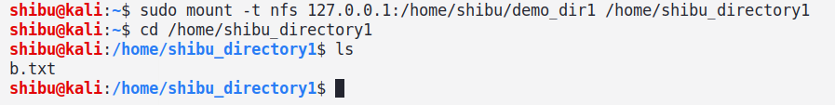

**PRACTICAL NO: 4**

**AIM:** SSH Server - Password Authentication Configure SSH server.

**THEORY:**

1. SSH Stands for - Secured Shell.
2. To tackle the issue of remote login vs password security a solution called Secured Shell (SSH) was developed.
3. It is a suite of network communication tools that are collectively based on protocol/standard i.e. guided by Internet Engineering Task Force (IETF).
4. The SSH command provides a secure encrypted connection between two hosts over an insecure network.
5. The connection can also be used for terminal access, file transfers & for tunnelling other applications.
6. OpenSSH - Open Source Implementations

SSH provides an authentication mechanism based on cryptographic keys, called the "Public Key Authentication".

Port:

* 1. SSH client connection - Port number: 22
  2. Telnet client connection - Port number: 23

If we need to change, enter port number between 1024 and 32767.

**COMMANDS & OUTPUT:**

1. Install SSH server:

$ sudo apt-get -y install openssh-server

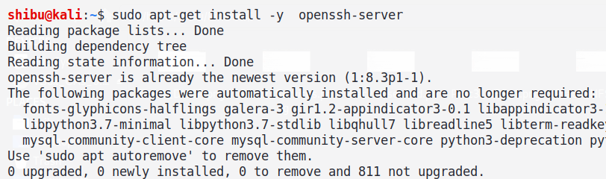

1. Now enable & check the status of SSH:

$ sudo systemctl enable ssh

$ sudo systemctl status ssh

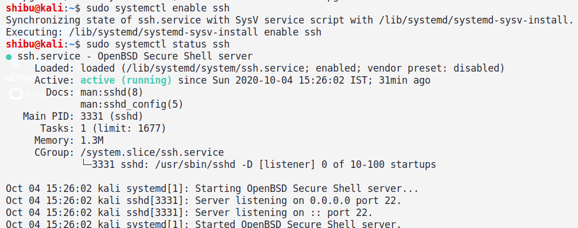

Now if there is any configuration to be changed, then it can be changed from the sshd file.

**Note:** To be on the safe side, user can install ufw (Uncomplicated Firewall), ufw provides a user-friendly way to create an IPv4 or IPv6 host-based firewall.

To install ufw, the command is:

$ sudo apt-get -y install ufw

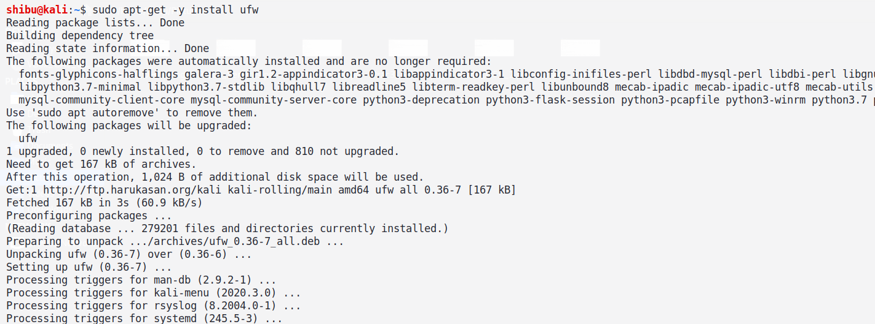

1. Now To configure user's server to allow incoming SSH connections:

$ sudo ufw allow ssh



$ sudo ufw allow ssh

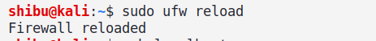

1. After this user can connect to the ssh localhost by the command:

$ ssh localhost (OR) $ ssh 127.0.0.1

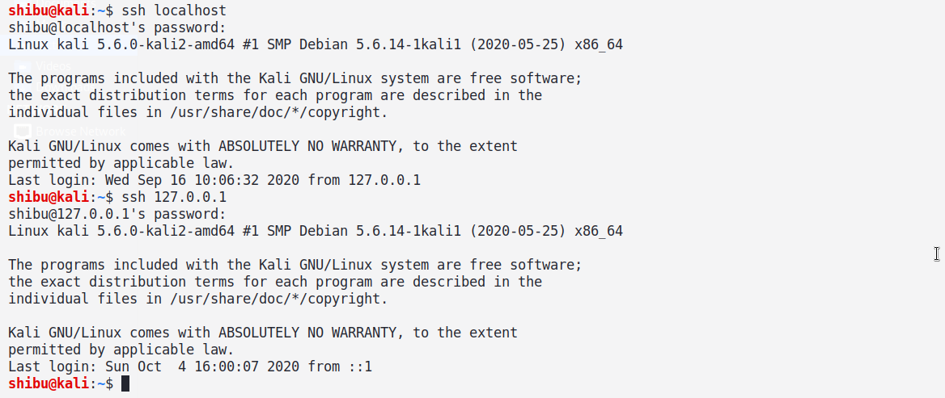

After this user can enter the root password to connect to the localhost.

**PRACTICAL NO: 5**

**AIM:** Install Samba to share folders or files between Windows and Linux.

**THEORY:**

1. Samba is an open source implementation of the Server Message Block/Common Internet File System (SMB/CIFS) protocol suite.
2. Samba transparently provides file and print sharing services to Windows clients as well as other networked clients running other operating systems.
3. It does this using the native Microsoft networking protocols SMB/CIFS.
4. From a system administrator’s point of view,
5. this means you can deploy a Linux/UNIX-based server without having to install Network File System (NFS) and some kind of
6. Linux/UNIX compatible authentication support on all the Windows clients in the network.
7. Instead, the clients can use their native tongue to talk to the server—which means fewer hassles for you and seamless integration for your users.

**COMMANDS & OUTPUT (Kali Linux Part):**

1. First, we need to install Samba Server:

$ sudo apt-get -y install samba

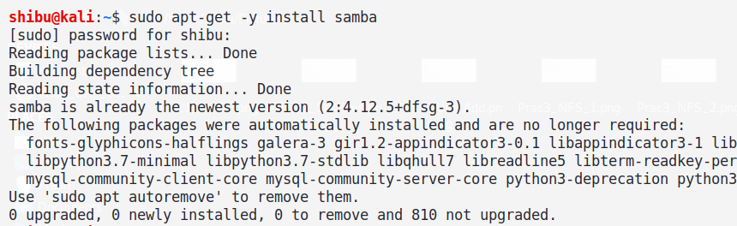

1. Then we need to start & check status of smbd:

$ sudo systemctl start smbd

$ sudo systemctl status smbd

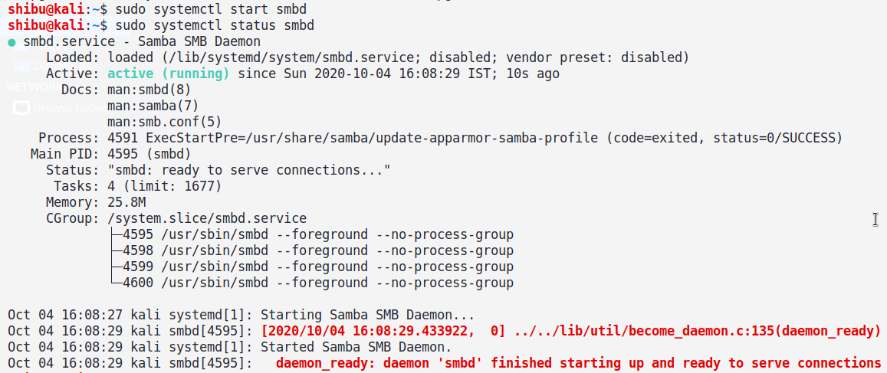

1. Then we need to start & check status of nmbd:

$ sudo systemctl start nmbd

$ sudo systemctl status nmbd

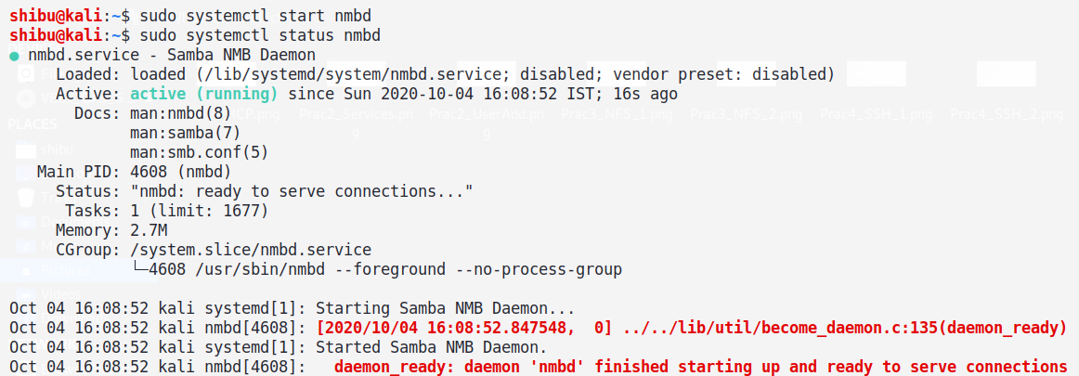

1. First, we make a samba_shared directory in /home/shibu

Then we make few txt files in /home/shibu/samba_shared

$ sudo mkdir samba_shared

$ touch a.txt b.txt c.txt

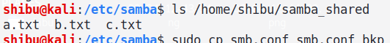

1. Now,

$ cd /etc/samba

$ ls /etc/samba

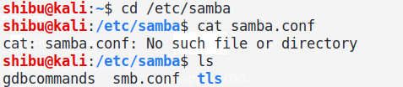

1. Now take the backup of smb.conf

$ sudo cp smb.conf smb.conf_bkp

$ car smb.conf_bkp

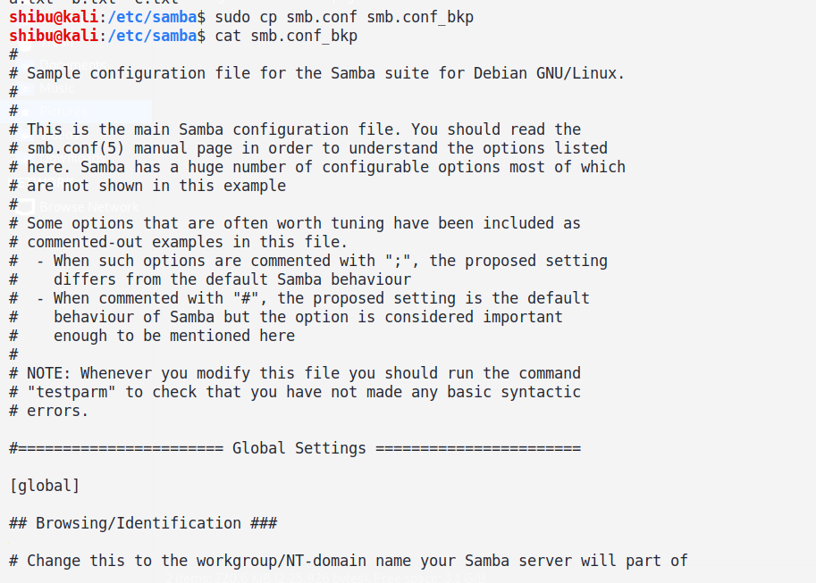

1. Now we need to do few configuration in /etc/smb.conf

Then delete all the things inside smb.conf and then write:

**[samba_shared]**

**comment = Welcome to samba**

**path = /home/shibu/samba_shared**

**browseable = yes**

**read only = yes**

**guest ok = no**

$ sudo nano smb.conf

$ sudo cat smb.conf

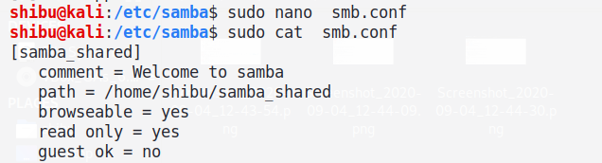

1. Now download smbclient:

$ sudo apt-get -y install smbclient

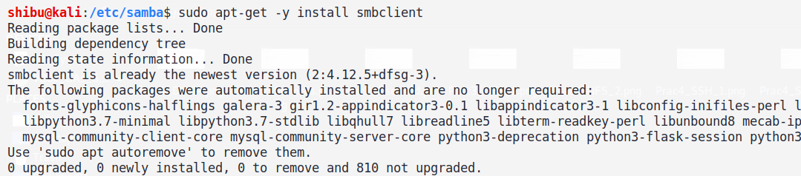

1. Now restart services of both smbd and nmbd & check their status too

$ sudo systemctl restart smbd

$ sudo systemctl restart nmbd

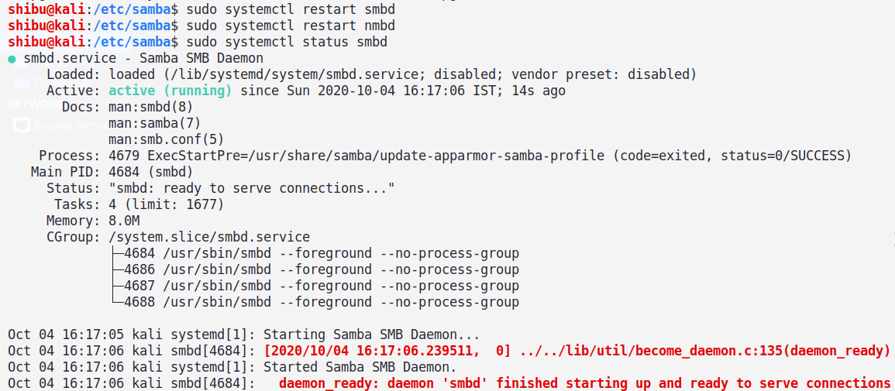

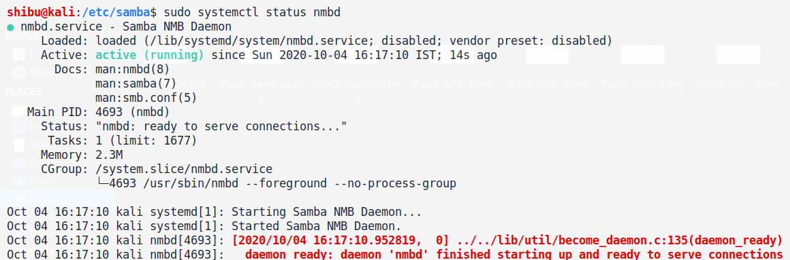

1. First do:

$ whoami



1. And then:

$ sudo pdbedit -a -u $(whoami)

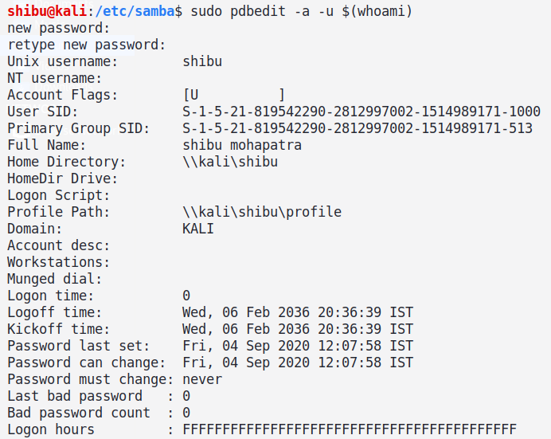

1. Type and retype your password:

$ sudo pdbedit -L (to check all users)

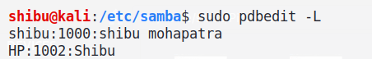

1. To check for your ip:

$ ip a (OR) $ ip addr

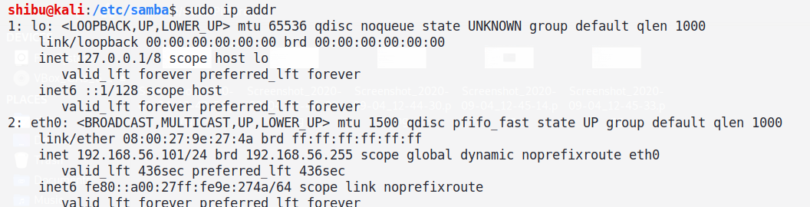

1. This will make any connection possible to connect:

$ sudo ufw allow from (your ip addr) any app Samba

In my case it was:

$ sudo ufw allow from 192.168.56.0/24 to any app Samba

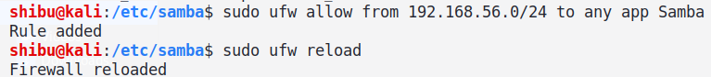

1. Now to reload your firewall use:

$ sudo ufw reload



1. To check whether it's working or not, use:

$ sudo smbclient -U <username> -L //your ip

In my case it was:

$ sudo smbcllient -U shibu -L //192.168.56.101

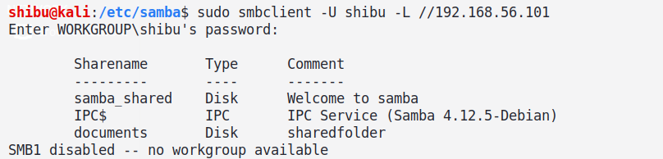

1. Now restart both smbd and nmbd & check their status too

$ sudo systemctl restart smbd

$ sudo systemctl restart nmbd

$ sudo systemctl status smbd

$ sudo systemctl status nmbd

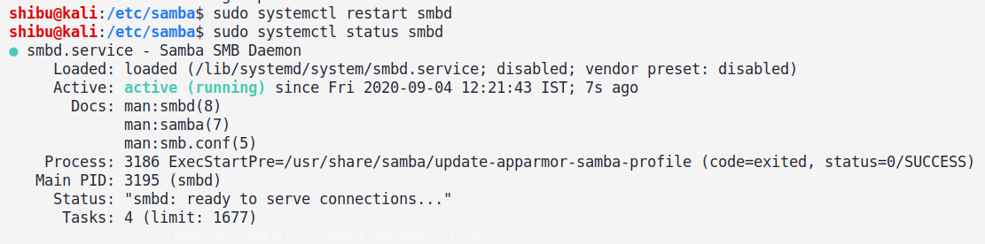

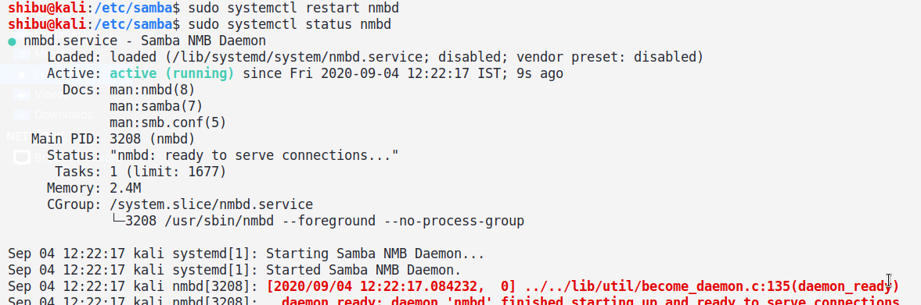

**Windows OS Part:**

1. Once smbd and nmbd services are active now switch back to your windows OS and press windows + R key on keyboard and

now a pop up box will open and their write smbclient ip address, here in my case it was //192.168.56.101 and press OK.

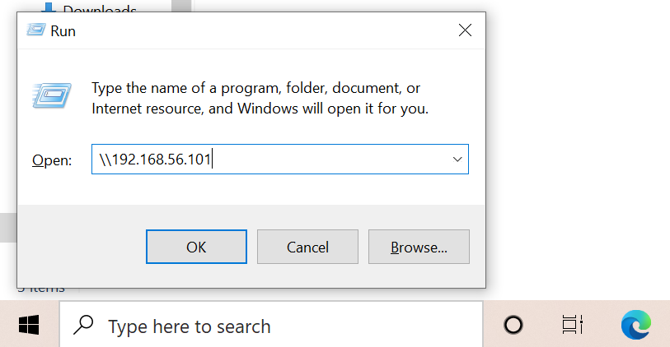

1. Now again one more pop up box will open, write the credentials of your Windows or Kali or whatever it would be.

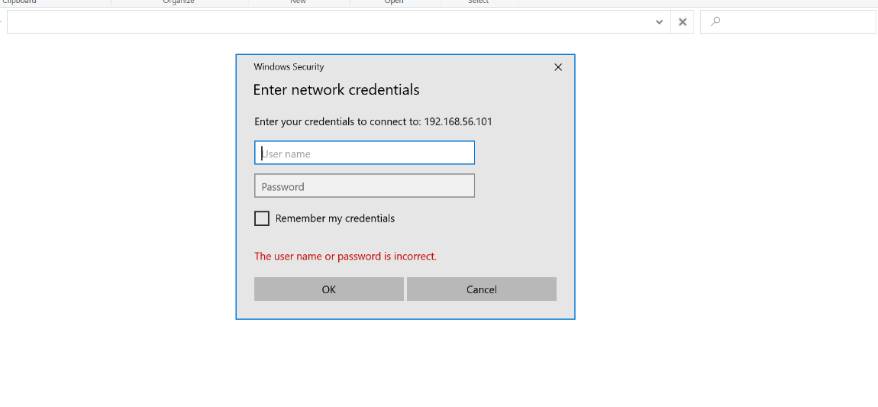

1. Now in top of the address bar you can see Network > 192.168.56.101 (your ip address) in this you can see samba_shared and documents folder.

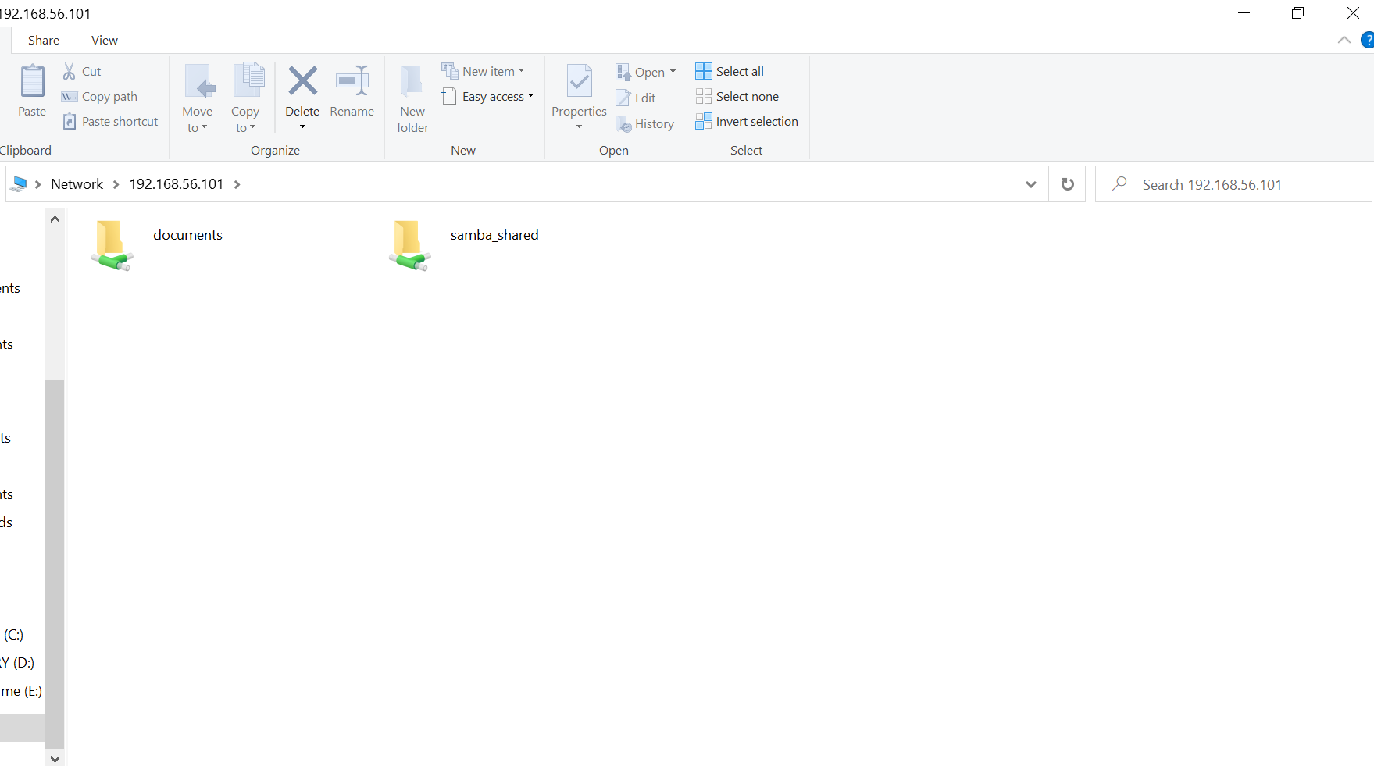

1. In samba_shared server you can see all the txt files that we've made earlier, using touch command.

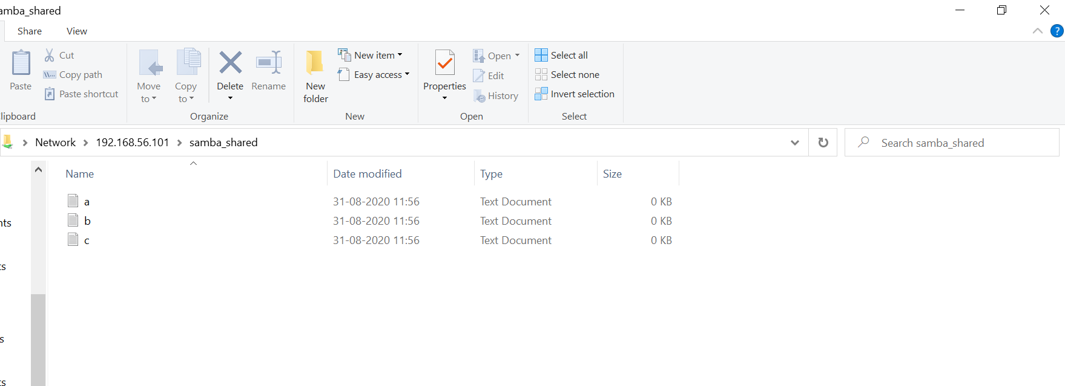

1. Once all your samba_shared files are visible in windows, then the sharing of files/folders have been successfully done between Windows and Kali Linux.

**PRACTICAL NO: 6**

**AIM:** Configure NTP, Install and Configure NTP Server, Configure NTP Client.

**THEORY:**

1. NTP- (Port number - 123)

* NTP stands for Network Time Protocol, and it is an Internet protocol used to synchronize the clocks of computers to sometime reference.
* NTP is an Internet standard protocol.
* NTP time servers work within the TCP/IP suite and rely on User Datagram Protocol (UDP) port 123.

1. SNTP-

* SNTP (Simple Network Time Protocol) is basically also NTP,
* As a full implementation of the NTP protocol seemed too complicated for many systems, a simplified version of the protocol, namely SNTP had been defined.

1. FEATURES:
   1. NTP needs some reference clock that defines the true time to operate. All clocks are set towards that true time.
   2. NTP uses UTC as reference time.
   3. NTP is a fault-tolerant protocol that will automatically select the best of several available time sources to synchronize to.
   4. NTP is highly scalable: - A synchronization network may consist of several reference clocks.

Each node of such a network can exchange time information either bidirectional or unidirectional.

* 1. Having available several time sources, NTP can select the best candidates to build its estimate of the current time.

The protocol is highly accurate, using a resolution of less than a nanosecond (about 2^-32 seconds).

**COMMANDS & OUTPUT:**

1. We need update:

$ sudo apt update -y

$ uname -a

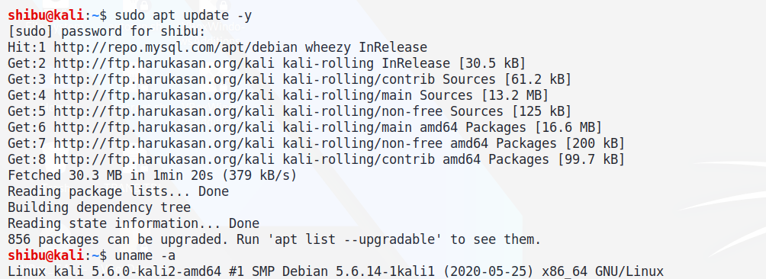

1. Command to install NTP:

$ sudo apt install ntp

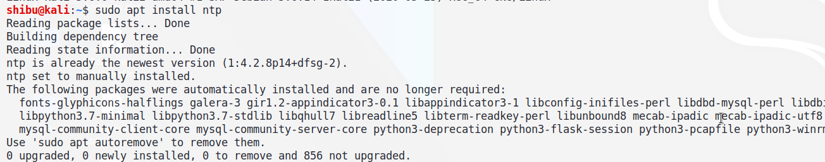

1. Command to install SNTP:

$ sudo apt install sntp

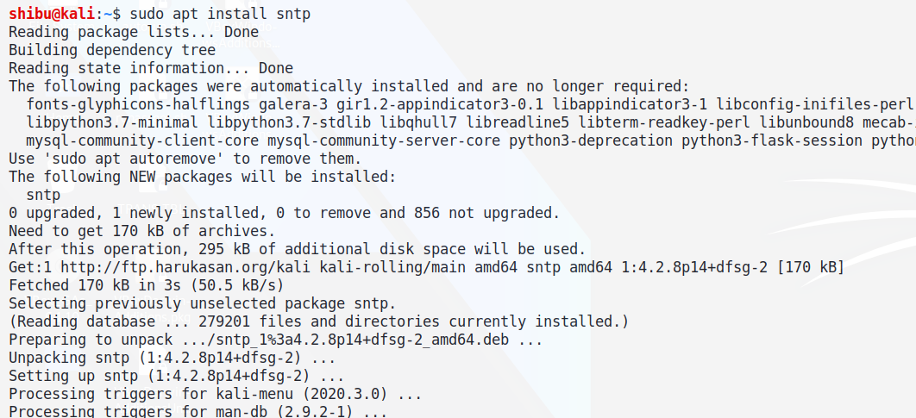

1. Now:

$ sudo sntp --version

$ cd /etc

$ ls -lrth *ntp.conf*

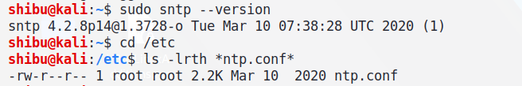

1. Then start & check status of NTP:

$ sudo systemctl start ntp

$ sudo systemctl status ntp

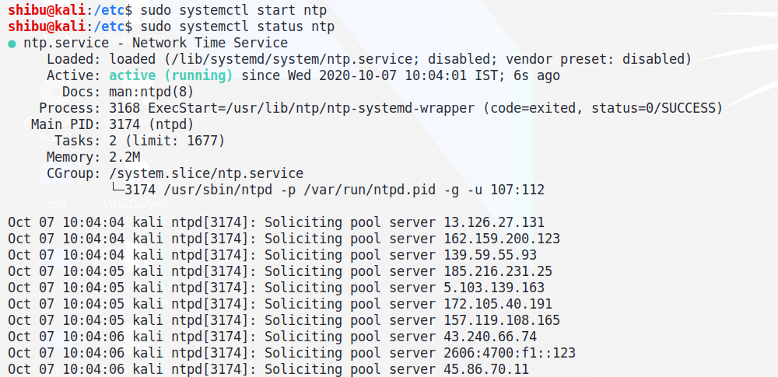

1. Now we need to configure NTP:

$ sudo vim /etc/ntp.conf



* After opening **ntp.conf** file scroll down and see-

**# You need to talk to an NTP server or two (or three)**

* Below this line write:

**server localhost**

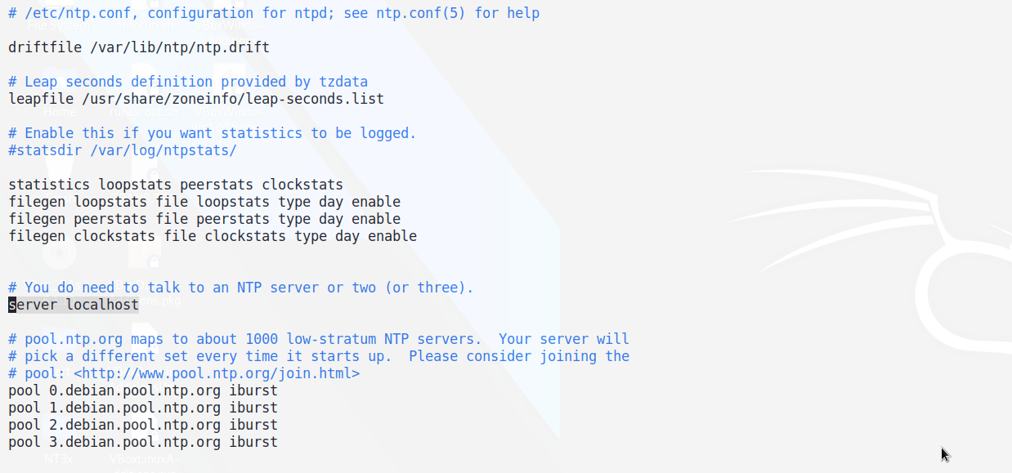

1. Then restart & check status of NTP:

$ sudo systemctl restart ntp

$ sudo systemctl status ntp

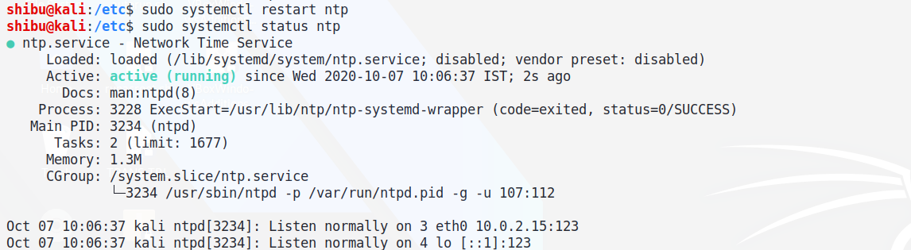

1. Now to query NTP and check its connection:

$ sudo ntpq -p

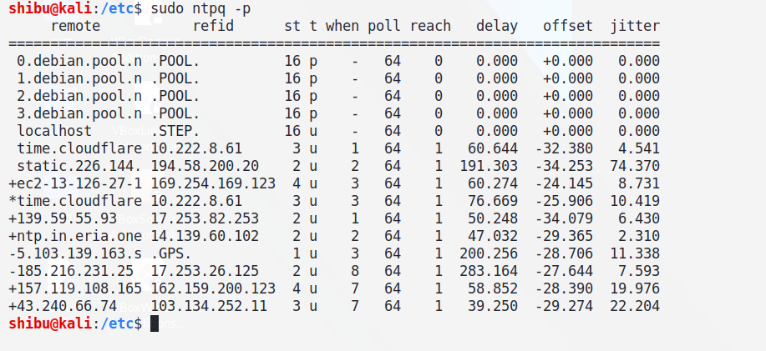

**PRACTICAL NO: 7**

**AIM:** Install MySQL to configure database server.

**THEORY:**

1. MySQL 8.0 is the latest stable release of MySQL relational database management system.
2. MySQL is a free to use Database Management System (RDBMS) that uses Structured Query Language (SQL).
3. MySQL is designed to be stable, reliable, and flexible to use.
4. Oracle provides Debian packages for installing MySQL on Debian or Debian-like Linux systems. The packages are available through two different channels:
5. The MySQL APT Repository, supporting Debian and Ubuntu platforms. “Installing MySQL on Linux Using the MySQL APT Repository”.
6. The MySQL Developer Zone's Download Area.

**COMMANDS & OUTPUT:**

1. We need update:

$ sudo apt update

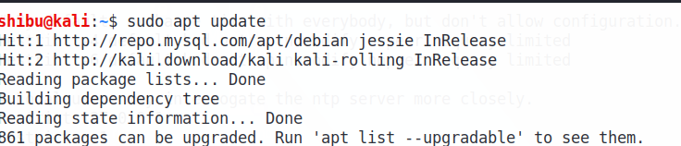

1. Then install wget:

$ sudo apt install -y wget

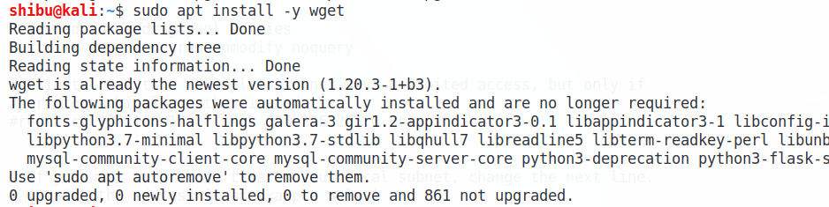

1. Then we need to wget the MySQL deb files:

$ sudo apt install -y wget <https://dev.mysql.com/get/mysql-apt-config_0.8.15-1_all.deb>

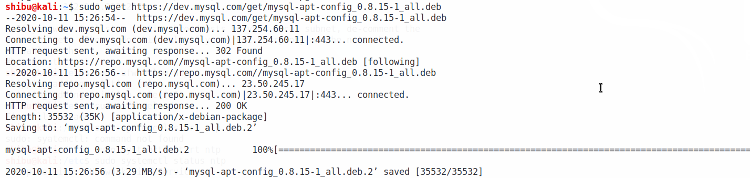

1. Install the deb files:

$ sudo dpkg -i mysql-apt-config_0.8.15-1_all.deb

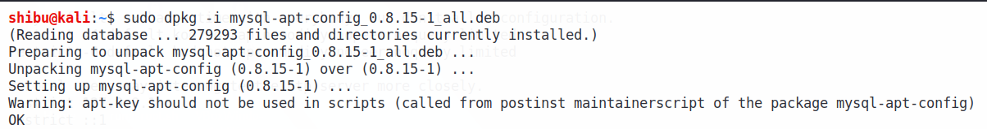

As Kali Linux is not officially supported version, choose the Ubuntu Bionic release.

Select **<OK>** and press **<Enter>** key to confirm version installation.

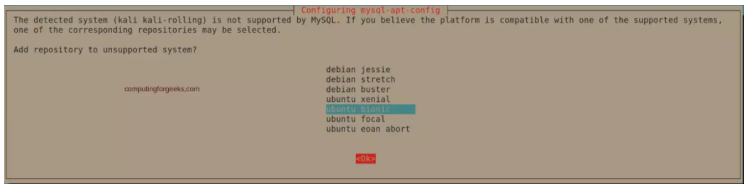

1. We need to & update install mysql-community-server:

$ sudo apt update

$ sudo apt install mysql-community-server

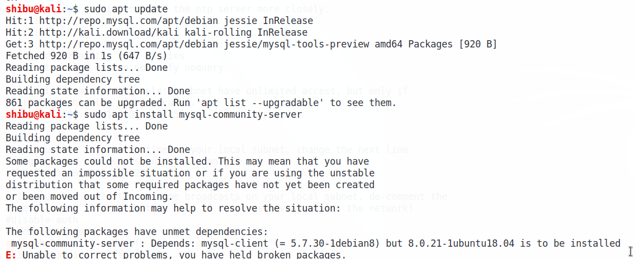

Accept license agreement in the next screens to begin installation.

Set root password for your MySQL database server.

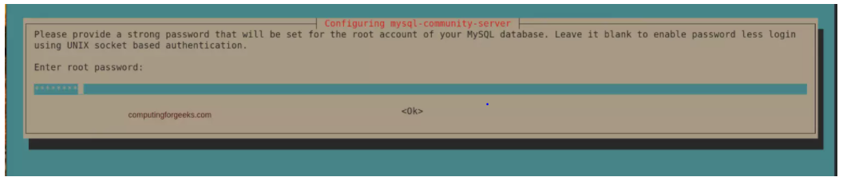

Confirm your root password.

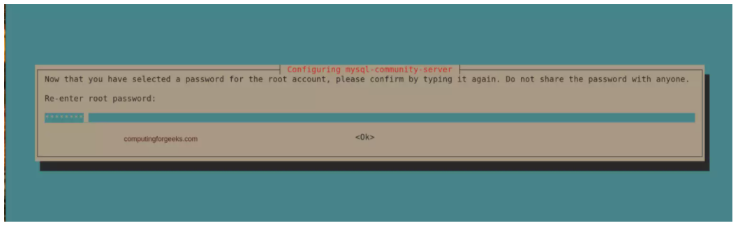

Select the default authentication plugin.

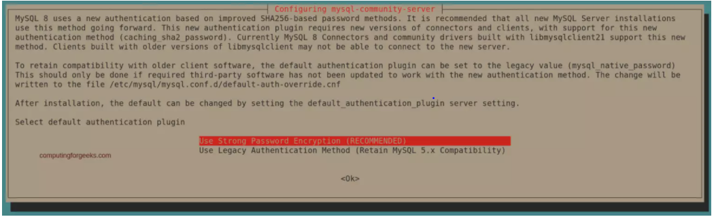

1. Now enable & check MySQL status:

$ sudo systemctl enable --now mysql

$ sudo systemctl status mysql

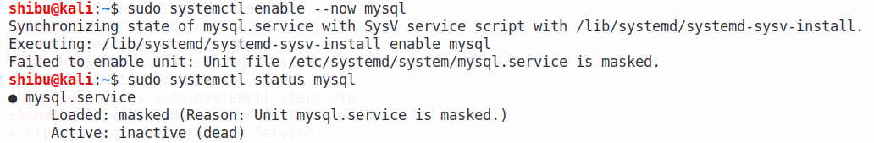

1. To test if the database server is working fine by creating a test database:

$ sudo mysql -u root -p

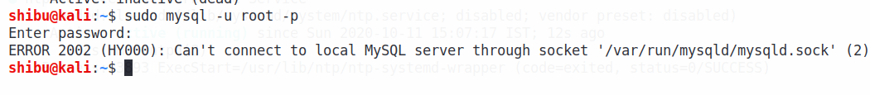

**PRACTICAL NO: 8**

**AIM:** Configure NIS in order to share user accounts in your local network.

**THEORY:**

* NIS stands for Network Information Systems.
* NIS, or Network Information Systems, is a network service that allows authentication and login information to be stored on a centrally located server.
* This includes the username and password database for login authentication, database of user groups, and the locations of home directories.
* NIS-sharing flat files (sharing resources).
* Files stored on certain machines, kind of database, can be queried, in tabular form, at least one column should be there.
* It is kind of kind of database in which each table has unique key, one or more column.
* And with query we need to identify it.
* There are 2 types:
  1. Master – Main Server
  2. Slave – Secondary server, load balancing

If master server goes down then the Slave can take over Master server.

* Client can join without server acceptance

**COMMANDS & OUTPUT:**

1. First update kali:

$ sudo apt-get update

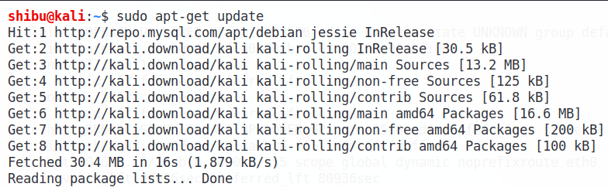

$ sudo apt update

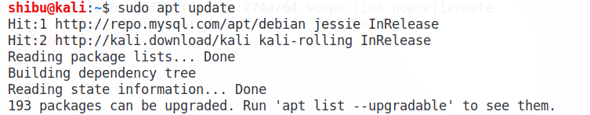

1. Now install NIS:

$ sudo apt-get install -y nis

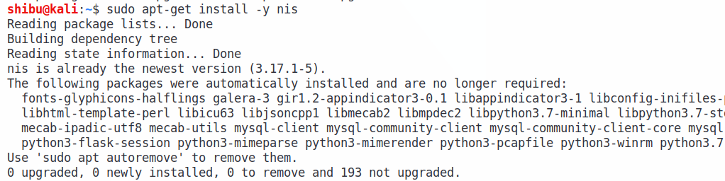

1. Now user must configure NIS:

$ sudo nano /etc/default/nis



* After opening **/etc/default/nis** file scroll down and see-

**#** **Are we a NIS server and if so what kind (values: false, slave, master)?**

* And write:

**NISSERVER=master**

* And then scroll below

**# Are we a NIS client?**

* And write:

**NISCLIENT=false**

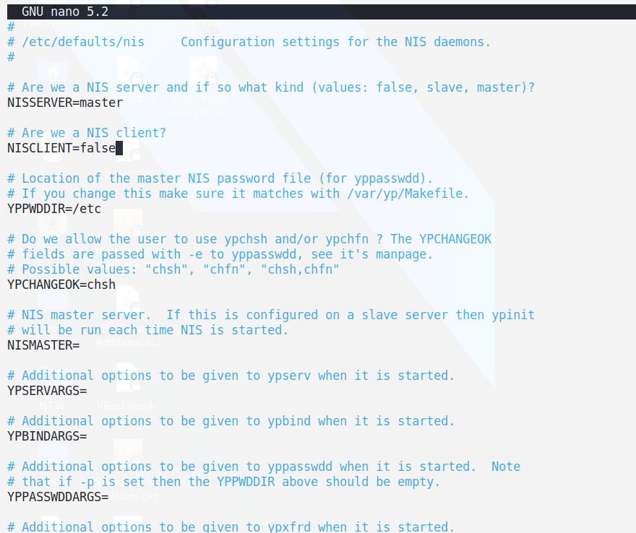

1. Take copy of NIS:

$ sudo cp /etc/default/nis /etc/default/nis_client

1. In /etc/ypserv.securenets, we need to write our IP address and subnet mask:

$ sudo nano /etc/ypserv.securenets



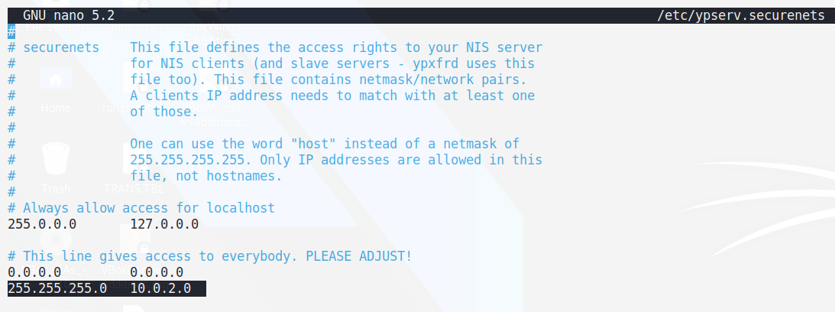

1. Now for gmake (**GNU** make - called simply make on Linux systems) is a tool to help you build a program from its source.

$ which gmake

$ sudo dpkg -S `which gmake`



1. Now start & check the status of ypserv:

* ypserv: yellow pages (directory), it's a server where a client can query to see what service is there.
* ypbind: Client binds tools
* ypxfrd: nis database is with master, this command sends the database to the slave (secondary server) - load balancing

$ sudo systemctl start ypserv

$ sudo systemctl status ypserv

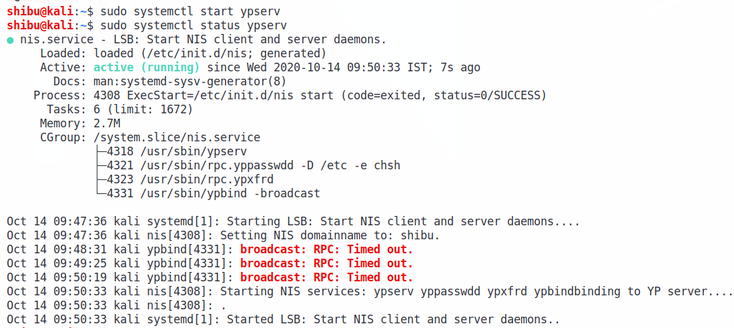

1. Now run the yp:

$ sudo /usr/lib/yp/ypinit -m

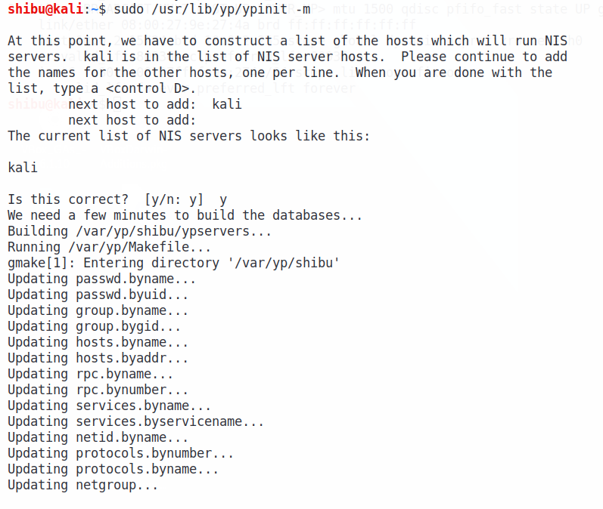

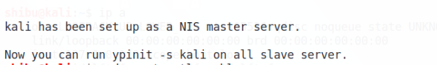

1. Now start & check status of NIS:

$ sudo systemctl start nis

$ sudo systemctl status nis

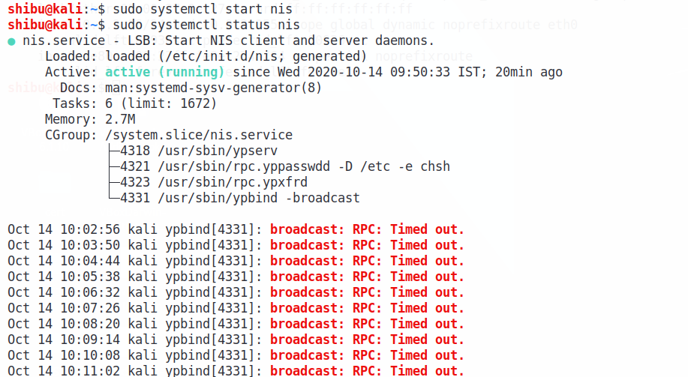

1. Restart and check status of rpcbind NIS:

$ sudo systemctl restart rpcbind nis

$ sudo systemctl status rpcbind nis

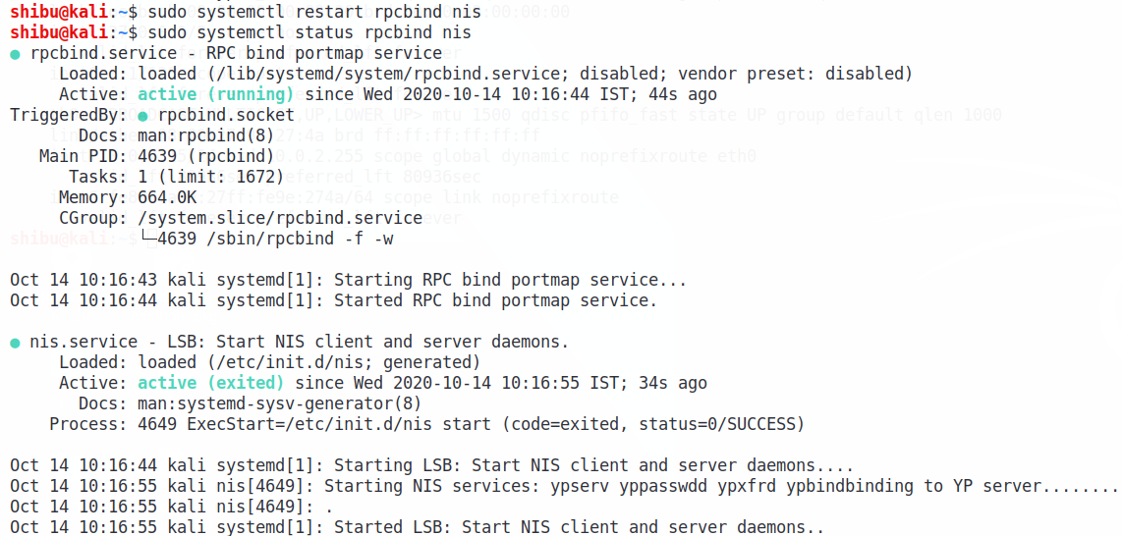

1. Now we need to Add a user:

$ sudo adduser shibu9

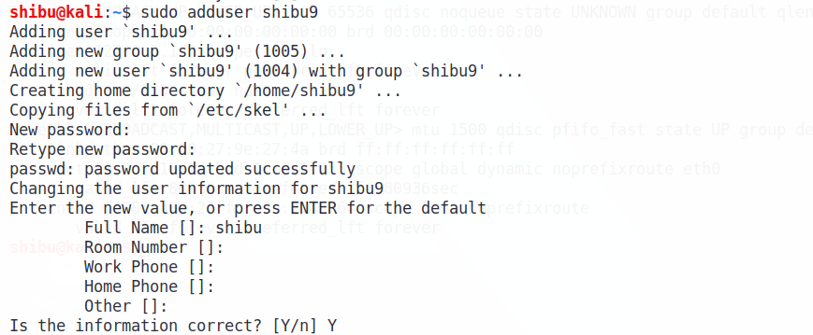

1. Now to make your user:

$ cd /var/yp

$ sudo make

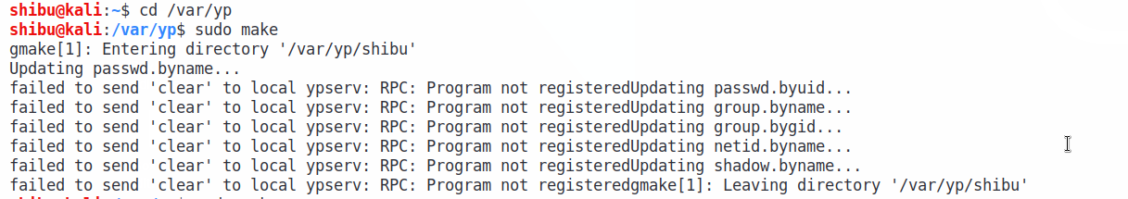

1. Now add a hostname in /etc/host: (I’ve added **kali.shibu** )

$ sudo nano /etc/hosts



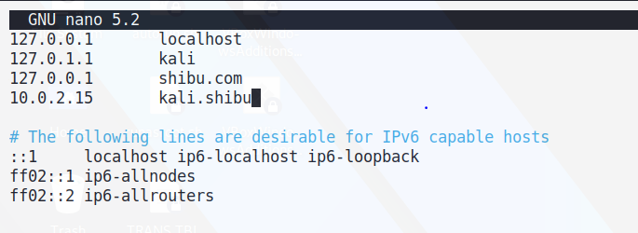

1. In /etc/yp.conf/ write the domain and server

In my case I’ve written domain as Shibu and server as kali.shibu

$ sudo nano /etc/yp.conf



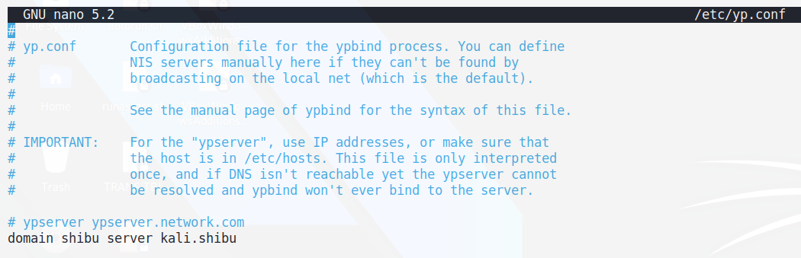

1. Now, do $ ls -lrth

$ cat ypservers

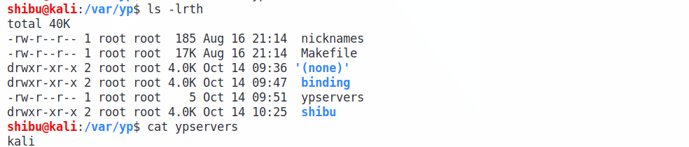

1. Now do hosts.byname name to see all your host name & domain name

$ sudo cat hosts.byname

$ sudo domainname

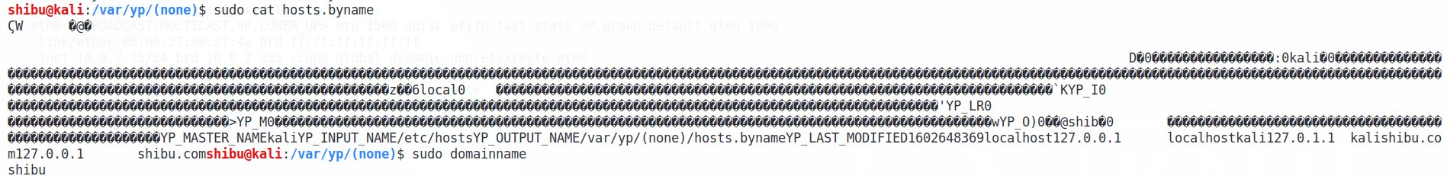

1. Now ping, just to check everything’s working:

$ ping kali

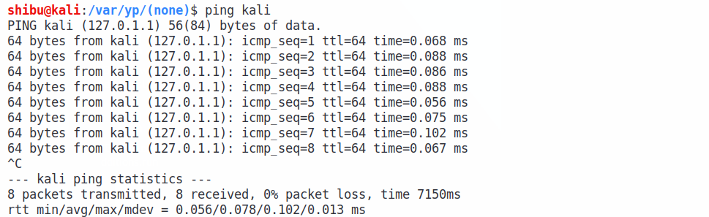

$ ping shibu.com

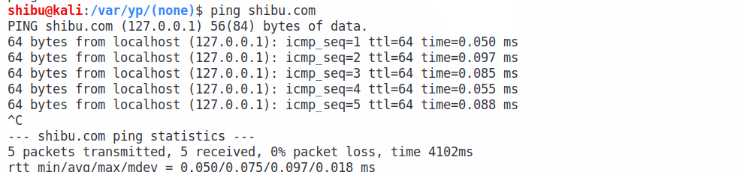

$ ping kali.shibu

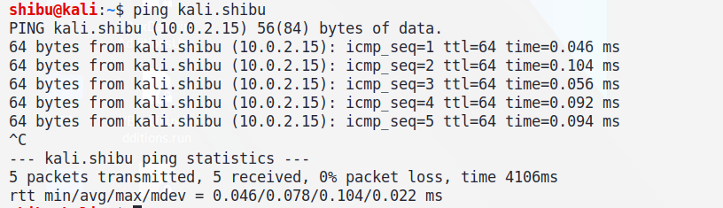

1. Now again run the yp:

$ sudo /usr/lib/yp/ypinit -m

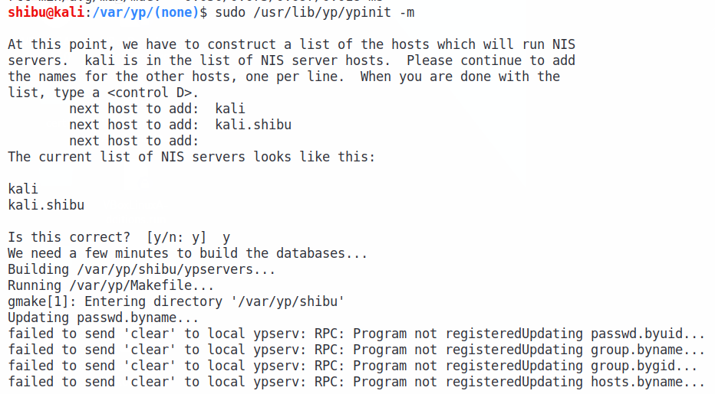



1. Now configure **nsswitch.conf** for NIS:

* The Name Service Switch (NSS) configuration file, /etc/nsswitch.conf, is used by the GNU C Library and certain other applications to determine the sources from which to obtain name-service information in a range of categories, and in what order.
* Each category of information is identified by a database name.

$ sudo nano /etc/nsswitch



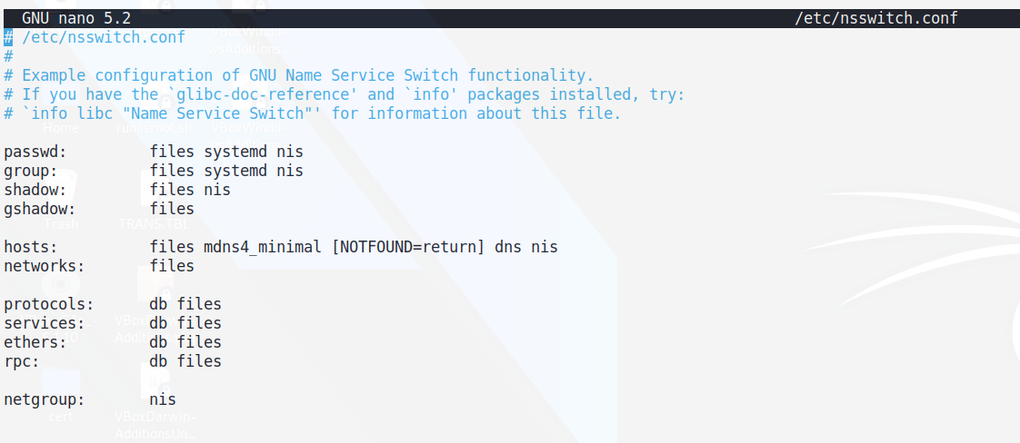

1. Now reboot Kali and Login with the user that we have added above:

$ sudo reboot



1. If Login is successful then NIS server is working.

